n Mini-Lesson 14.3, you learned how to upload and download files from containers. In this activity, you will download the folder and its files from a container to your local machine. Prior to beginning this activity, be sure to review the submission instructions below to ensure that you collect the required screenshots as you progress through the activity.
To complete this activity, follow these steps:
- Create a Docker container named ubuntu_container on your machine using the following command:
docker run --name ubuntu_container -dti ubuntu /bin/bash
Provide a screenshot to show that you successfully created the Docker container named ubuntu_container.
- Open your Docker Desktop and find the newly created Docker container, ubuntu_container. Select “CLI” to open the container command line interface. Provide a screenshot to show the ubuntu_container command line interface.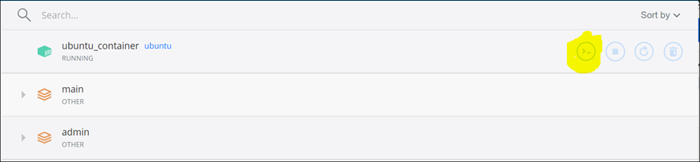
- In the ubuntu_container command line interface, change the folder to home and create a folder called container_activity_14.1 with a file in it titled container1.txt. Provide a screenshot to show that the container_activity_14.1 folder has been created with the container1.txt file in it.
- Change your folder to the container_activity_14.1 folder and create a sample file under the container_activity_14.1 folder called container1.txt using the echo command. Add the “Hello World” content below to the text file by using the following command:
echo "Hello World" > container_activity_14.1/container1.txt
Provide a screenshot to show that the container_activity_14.1 folder has been created and that it contains the container1.txt file with the “Hello World” content added to it.
- Open your local machine command prompt. Create a folder called local_activity_14.1 and navigate to the folder where you will download the container_activity_14.1 folder.
Provide two screenshots. Provide one screenshot to show that you created the local_activity_14.1 folder. Provide a second screenshot of your command line interface to show that you successfully changed your folder to the local_activity_14.1 folder.
- Perform a docker copy command from your local machine command prompt to get the container_activity_14.1 folder from the container to your local machine folder, local_activity_14.1. Provide a screenshot to show that the docker cp command was executed successfully and there were no errors after copying the container_activity_14.1 folder.
- Validate the local machine local_activity_14.1 folder to determine whether it copied the container_activity_14.1 and its files correctly. Provide a screenshot of the folder to show that you successfully copied the container_activity_14.1 and its files folder to the local_activity_14.1 work folder.
Submission Instructions:
Your submission for this assignment should be a Word document that includes the following screenshots, each labelled for the step that the screenshot represents:
- Provide a screenshot to show that you successfully created the Docker container named ubuntu_container.
- Provide a screenshot to show the ubuntu_container command line interface.
- Provide a screenshot to show that the container_activity_14.1 folder has been created with a file in it titled container1.txt.
- Provide a screenshot to show that the container_activity_14.1 folder has been created and that it contains the container1.txt file with the “Hello World” content added to it.
- Provide two screenshots. Provide one screenshot to show that you created the local_activity_14.1 folder. Provide a second screenshot of your command line interface to show that you successfully changed your folder to the local_activity_14.1 folder.
- Provide a screenshot to show that the docker cp command was executed successfully and there were no errors after copying the container_activity_14.1 folder.
- Provide a screenshot of the folder to show that you successfully copied the container_activity_14.1 and its files folder to the local_activity_14.1 work folder.

